Lab Report Walkthrough – 3 (2.3.8)

Title: Accessing and Configuring Cisco Switch and Router via Console Connection

Objective
The objective of this lab was to:
- Access a Cisco 2960 switch using a console cable
- Access a Cisco 4321 router using a Mini-USB console cable
- Examine the iOS software version
- Configure and verify the system clock
- Understand User EXEC and Privileged EXEC modes
- Establish console sessions using Packet Tracer Terminal

Part 1: Access a Cisco Switch through the Serial Console Port
Step 1: Install and Investigate the Switch
In Part 1, we built the physical network according to the given topology.
- Placed one Cisco 2960 switch into the Rack.
- Verified physical ports using Inspect Front.
- Observed:
  - 24 FastEthernet ports
  - Additional uplink ports
- Verified presence of the Console port using Inspect Rear.
The switch powered on successfully.
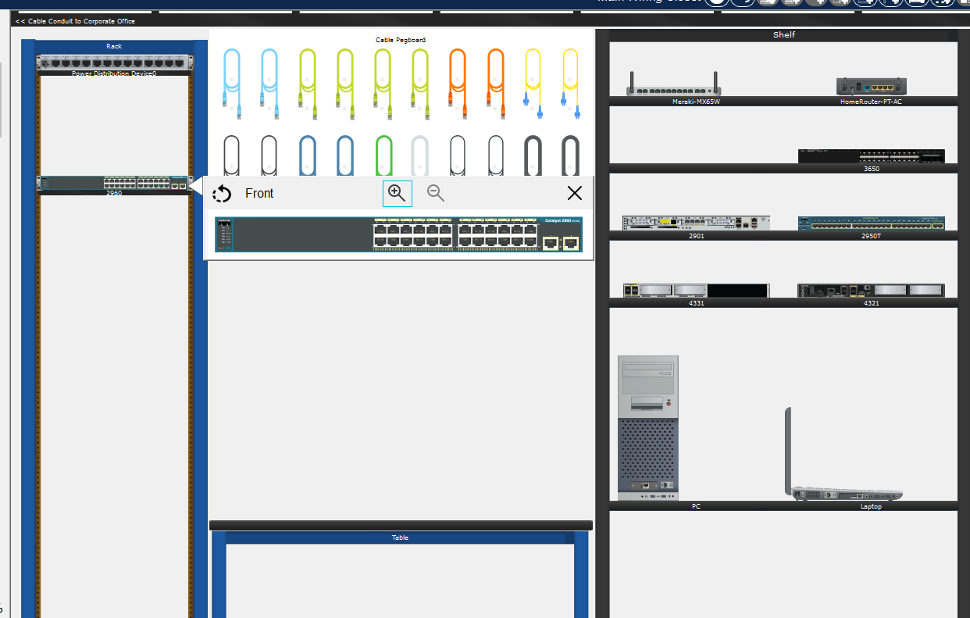
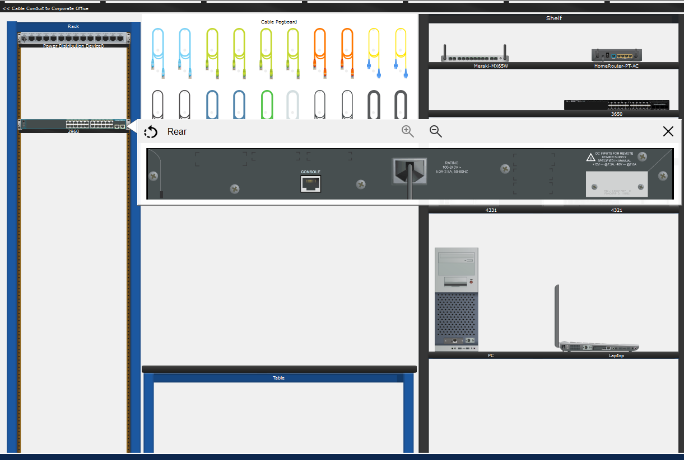

Step 2: Install and Prepare the PC
- Placed one PC on the workspace.
- Powered on the PC.
- Observed:
  - FastEthernet interface
  - RS232 serial port (for console connection)
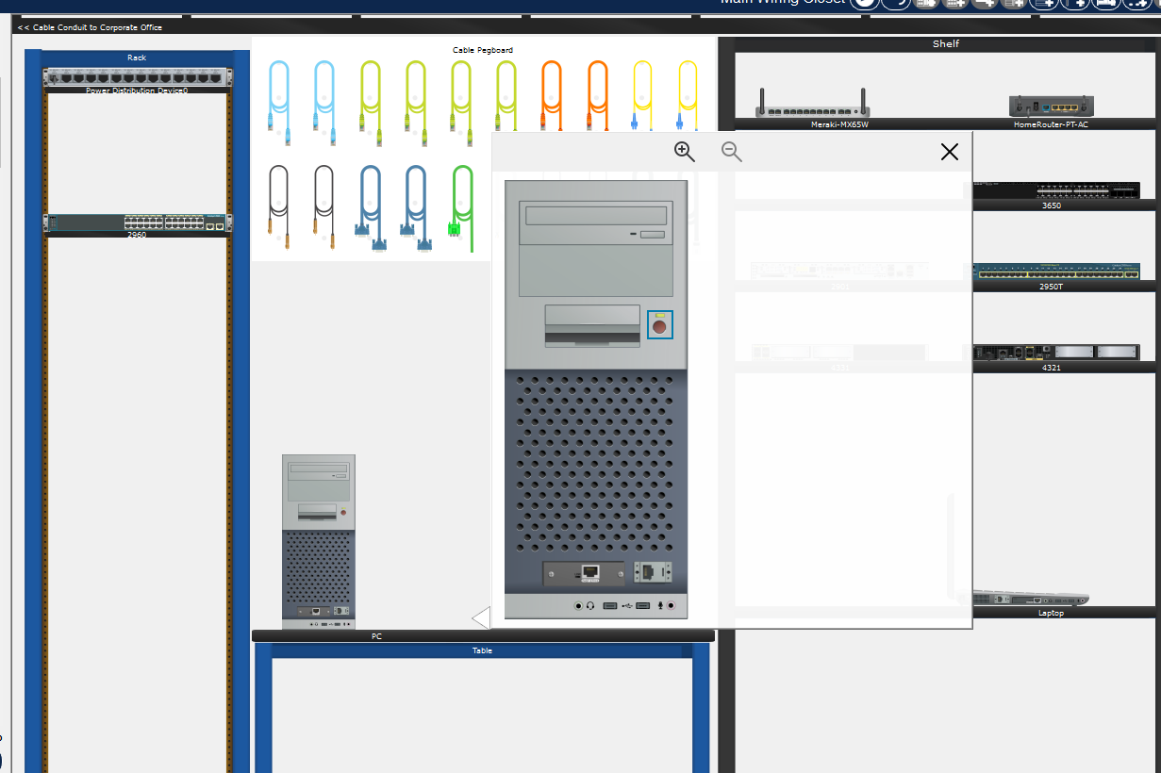

Step 3: Establish Console Connection
- Selected the Console (Rollover) cable.
- Connected:
  - PC RS232 port → Switch Console port
This established a physical console connection.
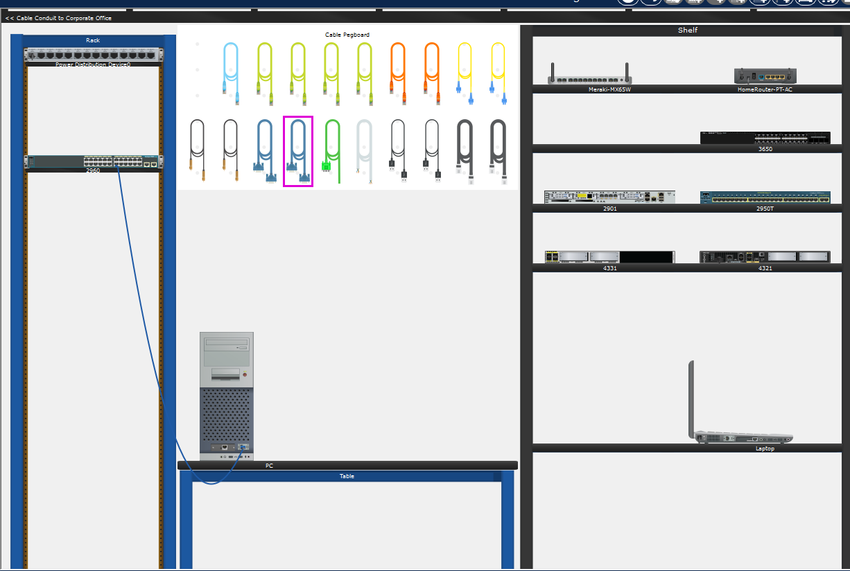

Step 4: Access the Switch CLI
- Opened PC → Desktop → Terminal.
- Accepted default serial communication settings:
  - 9600 baud
  - 8 data bits
  - No parity
  - 1 stop bit
  - No flow control
- Pressed Enter.
The following prompt appeared: Switch>
This confirmed successful access to the switch in User EXEC mode.
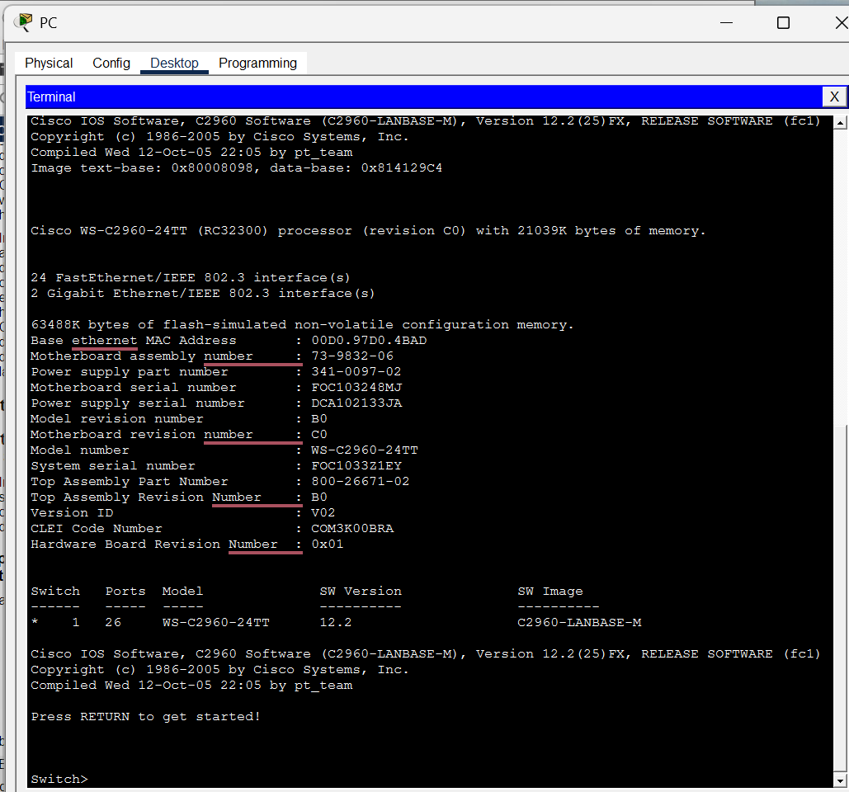

Part 2: Display and Configure Basic Device Settings
Step 1: Display IOS Version
From User EXEC mode: Switch> show version
The IOS image and version information were displayed, including:
- IOS image name
- Software version number
- Processor and memory details
This verified the currently installed IOS version.
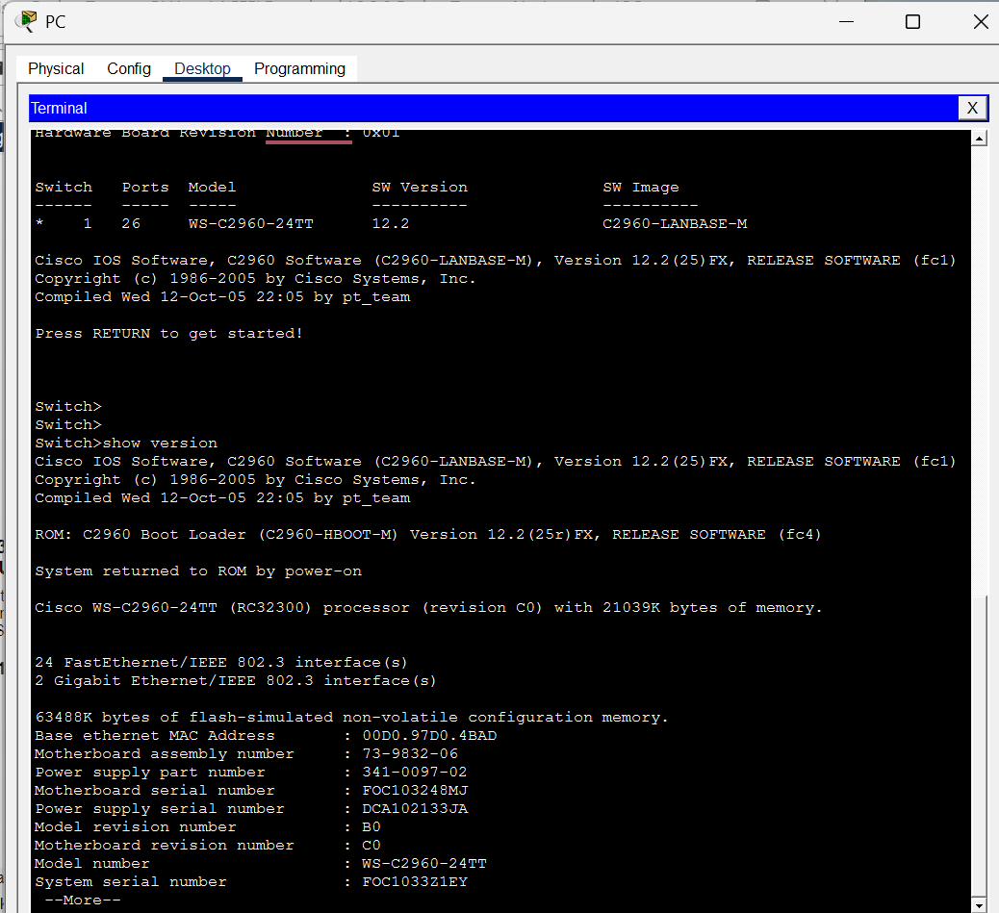

Step 2: Display Current Clock
From User EXEC mode: Switch> show clock
The default system date and time were displayed.
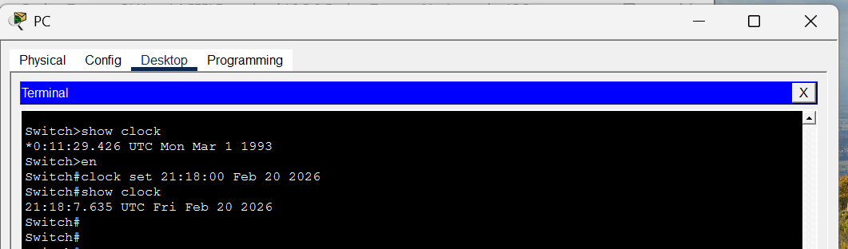

Step 3: Enter Privileged EXEC Mode
From User EXEC mode: Switch> enable
Switch#
The prompt changed to: Switch#
This indicates Privileged EXEC mode, allowing configuration changes.

Step 4: Configure System Clock
The clock was configured using:
Switch# clock set 21:18:00 Feb 20 2026
After configuration, verification was performed:
Switch# show clock
The updated date and time were displayed successfully.
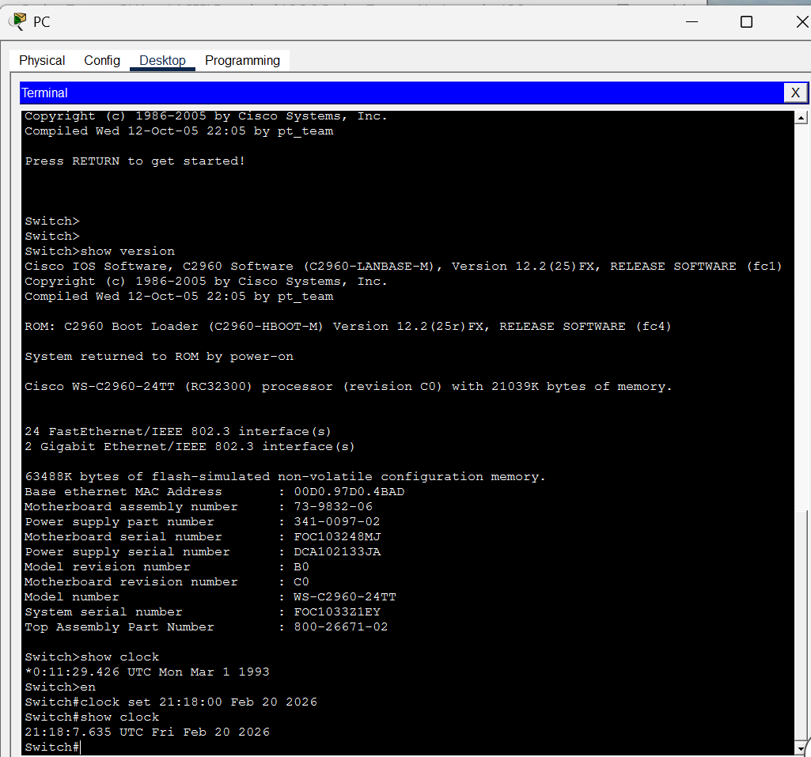

Part 3: Access a Cisco Router Using a Mini-USB Console Cable
Step 1: Install and Investigate the Router
- Placed the Cisco 4321 router into the Rack.
- Powered on the router.
- Observed:
  - Gigabit Ethernet ports
  - RJ-45 console port
  - Mini-USB console port
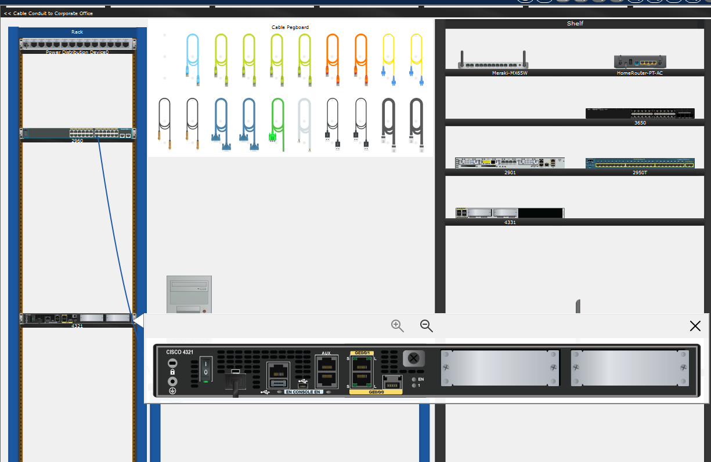

Step 2: Install and Prepare the Laptop
- Placed one Laptop on the workspace.
- Powered on the laptop.
- Verified availability of USB ports for console access.
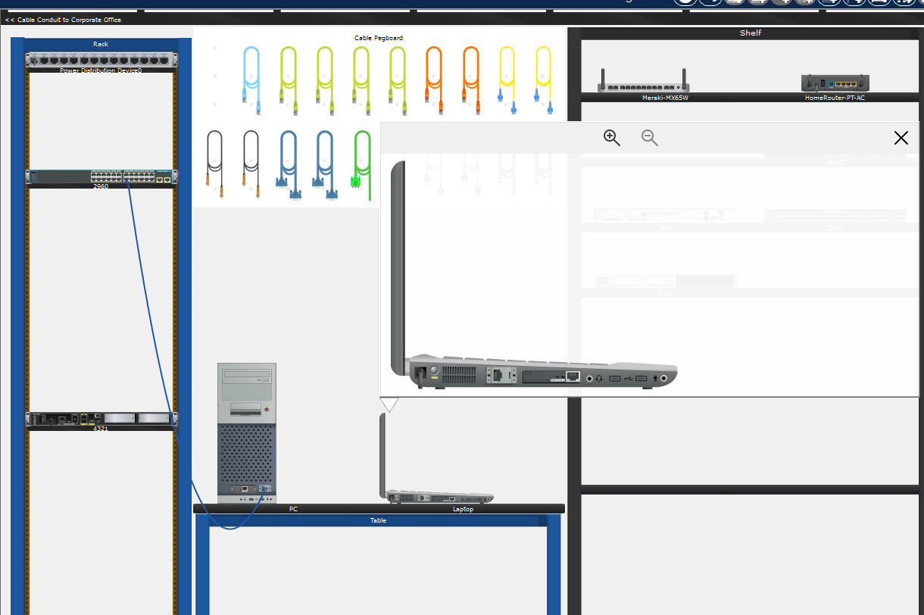

Step 3: Establish Mini-USB Console Connection
- Selected the USB to Mini-USB cable.
- Connected:
  - Laptop USB port → Router Mini-USB console port.
This created a console connection between the laptop and router.
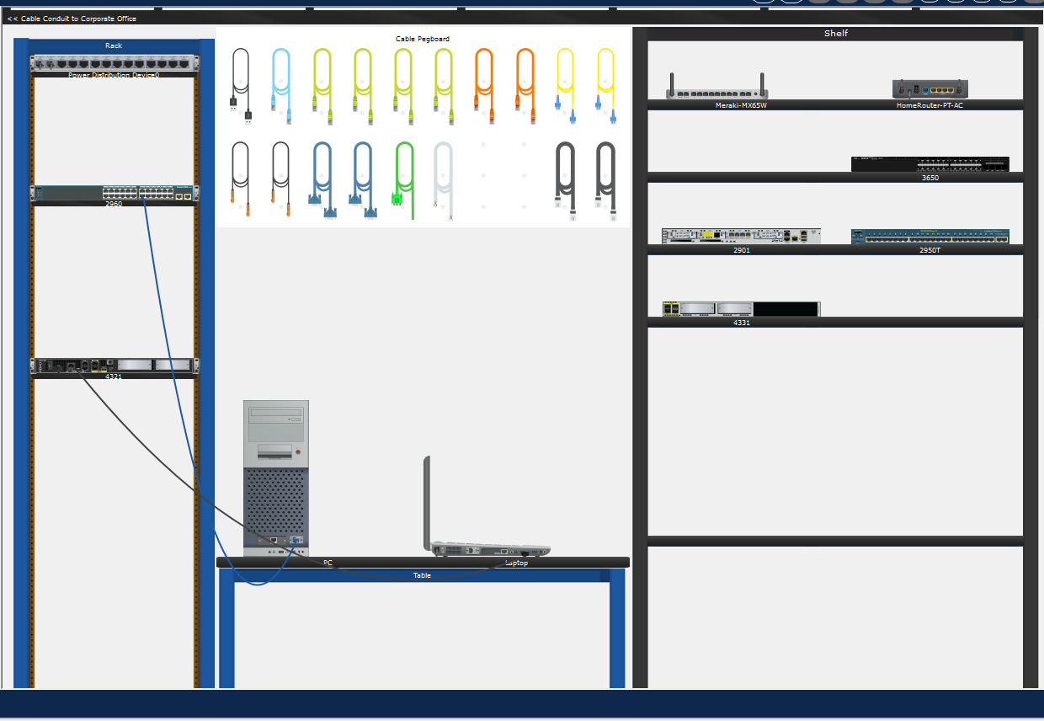

Step 4: Access Router CLI
- Opened Laptop → Desktop → Terminal.
- Accepted default settings.
- Waited for router initialization process to complete.
When prompted: Would you like to enter the initial configuration dialog? [yes/no]:
Entered: no
Pressed Enter to continue.
The following prompt appeared: Router>
This confirmed successful access to the router in User EXEC mode.
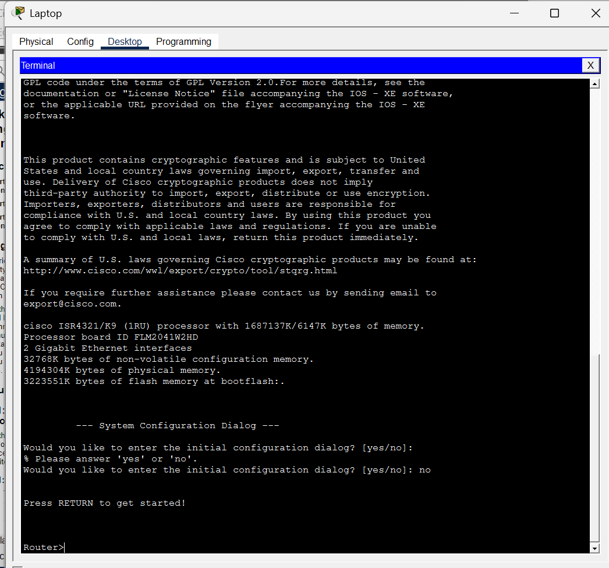

Verification
Successful completion was verified by:
- Access to switch CLI (Switch>)
- Access to router CLI (Router>)
- Display of IOS version information
- Successful modification of system clock
- No console connection errors

Conclusion
The objectives of this lab were successfully achieved. Console access was established for both the Cisco 2960 switch and Cisco 4321 router using appropriate console cables. The IOS version was examined, and the system clock was configured and verified.
This lab provided a practical understanding of:
- Physical console connectivity
- Serial communication parameters
- Cisco IOS operational modes
- Basic device verification commands
- Router initialization behavior
The lab was completed successfully.
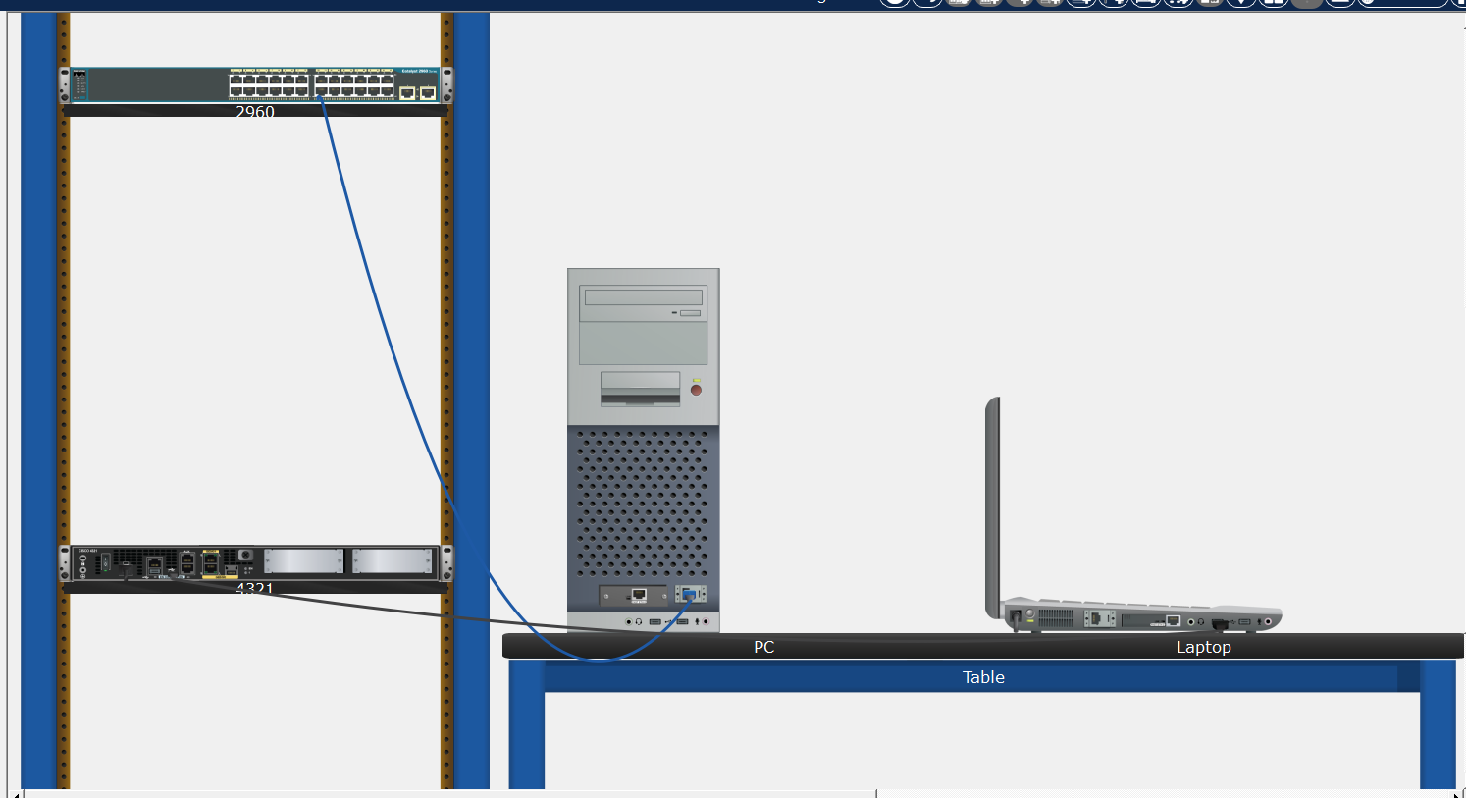

Reflection Questions: -
1. How do you prevent unauthorized personnel from accessing the Cisco device through the console port?
Unauthorized access through the console port can be prevented by implementing the following security measures: -
- Set a console password
line console 0
password cisco
login
- Use enables secret password
enable secret class
- Create username and password (login local)
username admin secret password123
line console 0
login local
- Configure a banner message
banner motd # Unauthorized access is prohibited #
- Keep devices in a locked and secure location
- Restrict physical access to networking equipment.
- Limit access to authorized personnel only.
Since the console port requires physical access, securing the equipment location is very important to prevent unauthorized personnel from accessing the Cisco device through the console port.

2. What are the advantages and disadvantages of using the serial console connection compared to the USB console connection to a Cisco router or switch?
The advantages and disadvantages of using the serial console connection compared to the USB console connection to a Cisco router or switch are: -
- Advantages of Serial Console (RJ-45 to RS232)
- Widely supported on older Cisco devices
- Very stable and reliable connection
- Does not require special drivers
- Commonly used in enterprise environments

- Disadvantages of Serial Console (RJ-45 to RS232)
  - Modern laptops often do not have RS232 ports
  - Requires a USB-to-Serial adapter in many cases
  - Slightly slower setup compared to USB

- Advantages of USB Console Connection
- Supported by modern laptops
- No need for serial adapters
- Faster and easier physical connection
- Convenient for new Cisco devices

- Disadvantages of USB Console
- May require driver installation
- Sometimes not supported on very old devices
- Slight compatibility issues in some operating systems
Note: -
Both serial and USB console connections serve the same purpose: accessing the device CLI locally. Serial console connections are more traditional and widely compatible with enterprise hardware, while USB console connections are more convenient for modern systems. The choice depends on device model availability and hardware compatibility.

